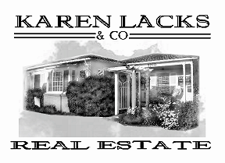

Karen D. Lacks Ramstrum, Broker
DRE #00576880
5210 Carpinteria Ave, Carpinteria, Ca 93013
Office: (805) 684-7559 Fax: (805) 684-7580

June 13, 2026

Elisabeth Shima
338 Oliver Road
Santa Barbara, CA 93109

Re: 207 W. Anapamu Street

Dear Aliza,

Please find attached the Comparative Market Analysis for the mixed use property located at 207 W. Anapamu Street. I applied the following considerations when evaluating the market value of your property as of March 24, 2026: number of units, number of bedrooms and bathrooms, age, condition/upgrades, square footage, lot size, property amenities and neighborhood. I compared similar properties that were actively marketed for sale, pending or closed within the prior 12 months.

207 W. Anapamu consists of 4 units: 1 commercial space (currently a neighborhood market approx. 1000 sq ft.) and 3 residential units (1 detached cottage approx. 1000 sq ft, and an attached duplex, approx. 500 sq ft per unit).

The Comparative Market Analysis shows 9 properties that best match the subject property. All comparative properties are residential multi-family/multi-unit properties similar in size, age and location to the subject property.

My opinion of value for 207 W. Anapamu $2,215,000 on March 24, 2026.

Should you need more information, I will be happy to provide it to you.

Sincerely,

Karen L. Ramstrum
Karen Lacks & Co. Real Estate

Enclosures

